**SMART ENERGY METERS USING IBM CLOUD**

**Features:**

* Measuring the voltage and current consumptions of the house
* calculating the electricity bills for the house and send them the notification.
* Develop a web application using which the persons can see the sensor parameters and the bills
* all the details will be stored in the database

**NODE RED**

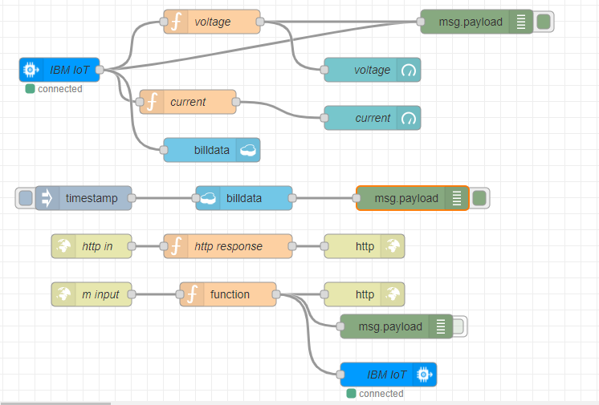

**NODE RED UI:**

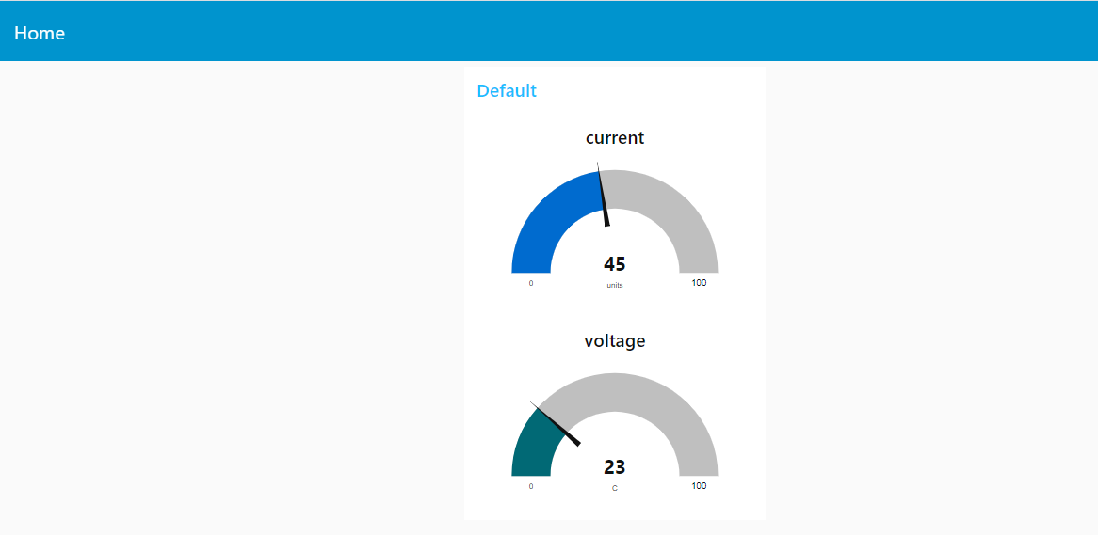

**CLOUDANT DATABASE OUTPUT:**

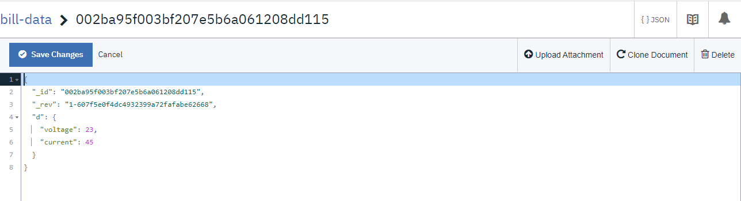

**SMS NOTIFICATION TO THE USER:**

